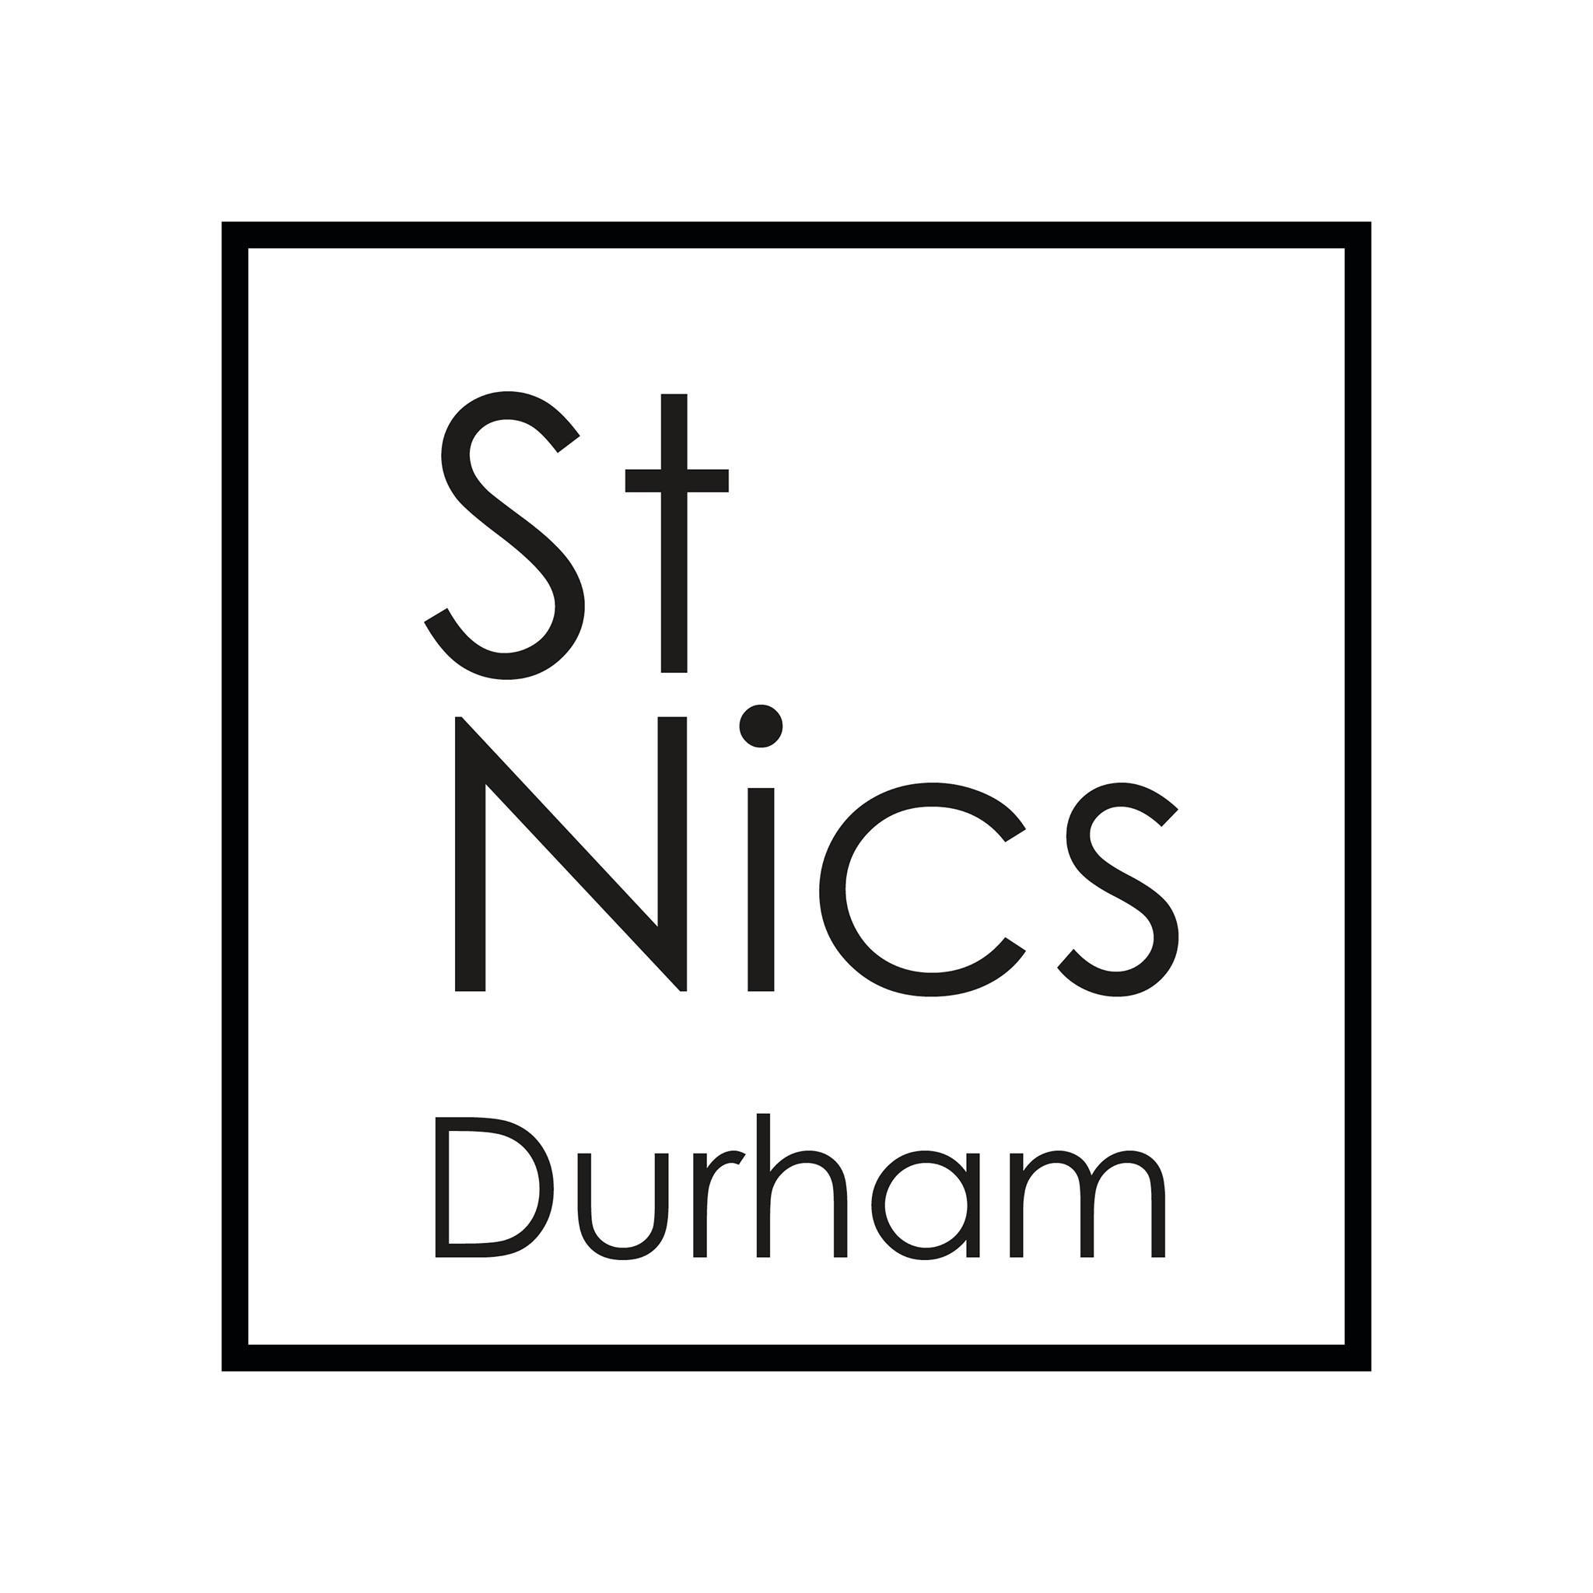

**Student & International Worker**

Full time

Salary: £ £19,760

Occupation requirement: Practising Christian

Location: St Nics Church, Market Place, Durham.

**The Person:**

We are seeking a faithful, enthusiastic and motivated Student and International Worker with a passion and dedication to seeing students grow in discipleship and service.

A confident self-starter, proactive, with good administration skills and able to set priorities; we are looking for someone with a heart for Jesus who will be able to lead a student team and be part of a staff team with a shared vision on discipleship and renewal.

**Job Description:**

This is a full time post - which works out as five days a week. This is split between internationals work and student work.

The postholder will lead and develop St Nics ministry with students in three key areas:

Student Discipleship:

* Oversee the proliferation of Spiritual Support Groups for Students as part of the Community of St Cuthbert
* Support the small group leaders and assistant student workers, discipling them so they can disciple others. Encourage those involved in student leadership through college CUs, mission events, bible studies
* Provide pastoral support to students working under supervision and with the support of the wider pastoral team

Student Mission:

●     Encourage and support innovative mission amongst students including justice projects both at Nics and more widely in the city.

●     Create spaces for non-Christians to connect with church e.g. Club Mission, invitational events, on-campus projects

●     Help the church welcome and integrate non- and new-Christian students

Student Leadership:

●     Identify student leaders (both in church and in wider contexts, e.g. Sports Society reps / Student Union reps etc)

●     Oversee and develop pathways for student discipleship involving others within the church community

●     Facilitate student engagement in wider church leadership

The postholder will also develop, promote and co-ordinate our ministry to international students and staff – working with a team of church volunteers.

* Devise and oversee a programme of activities
* Provide opportunities to explore the Bible and Christian faith for those who want to, either in person or with help from volunteers
* Develop volunteer involvement
* Raise the profile and ownership within the congregation, and develop the culture of welcome to international in the church
* Facilitating relationships and networks with relevant institutions

**Responsibilities**

**Vision** – You will cast vision for students and internationals to be participants in God’s kingdom purposes. Your role will develop vision and strategy for student and international ministry that is looking to multiply.

**Development & Support of leaders** – You will work with and provide support for the student team in leading and discipling other students. This includes mentoring, one-to-ones and team meetings.

**Discipleship & Training** – You will be actively involved in the discipleship of students and internationals, especially new Christians and those on a journey of faith. You will be involved in training others to do likewise.

**Community of St Cuthbert** – You will oversee the proliferation of spiritual support groups for students under the leadership of the Prior of the Community of St Cuthbert, bringing a passion for renewed discipleship across the church family.

**Communication** – You will take responsibility for communicating with students and internationals, including in digital formats and using digital tools, as well as feeding back to the staff team and leadership the experiences of students.

**Co-ordination** – You will provide co-ordination of international & student related activities (student night, lunches, invitational services, weekend away). You will link in with student and international church activity across Durham including freshers events, the annual CU Mission, Just Love events.

**Integration** – You will spearhead efforts to integrate students and internationals in to the wider life of St Nics through encouraging active participation in the variety of ministries and encouraging a culture of hospitality.

**Modelling** - You will have a responsibility to model a life of missional discipleship. You will be involved in the life of a missional community, have good accountability and develop friendships with people who don’t know Jesus.

**Relationships**- You will keep up good relationships with other student and internationals workers and organisations in the city.

**Personal Attributes:**

• A personal faith in Jesus Christ.

• A heart for seeing students come to faith and growing in discipleship

• An understanding of, and empathy with, the challenges of student life

• A team player – someone who is able to enthuse and inspire volunteers in their ministries at St Nics

• An eagerness to learn and develop, to try new things and work with flexibility and enthusiasm.

• Ability to respect matters of confidentiality and sensitivity.

• Vision, initiative, and self motivation.

**Skills**

• Excellent pastoral skills with students, including post graduates

• Confident IT skills with knowledge of varied social media channels.

• Excellent literacy and numeracy.

• Strong ability to come alongside and develop others.

• Strong organisational and time management skills.

• Knowledge of and commitment to good practice in Safeguarding.

There is a genuine occupational requirement that the post holder is a Christian. The post is subject to an Enhanced DBS disclosure.

**Person Specification**

|  |  |  |
| --- | --- | --- |
|  | **Essential** | **Desirable** |
| **Qualifications** | Degree level | Evidence of Theological study or qualification |
| **Experience** | Experience in leading students  Experience in discipling others  Experience of working week in a team setting  Experience of working well with volunteers  Experience of planning and delivering events |  |
| **Skills & Abilities** | An understanding of current student issues  Excellent pastoral skills with students, including post graduates  Confident IT skills with knowledge of varied social media channels.  Excellent literacy and numeracy.  Strong organisational and time management skills.  Knowledge of and commitment to good practice in Safeguarding.  A proven networker and communicator  Ability to work within a wider staff team |  |
| **Personal Qualities** | A personal faith in Jesus Christ.  A heart for seeing students come to faith and growing in discipleship  An understanding of, and empathy with, the challenges of student life  An eagerness to learn and develop, to try new things and work with flexibility and enthusiasm.  Ability to respect matters of confidentiality and sensitivity.  Ability to model a missional lifestyle |  |

There is a genuine occupational requirement that the post holder is a Christian.

The post is subject to an Enhanced DBS disclosure.

**Benefits**

* St Nics will seek to develop the post holder towards their full potential
* 25 days holiday, plus bank holidays
* Contributory Pension
* The chance to be part of a fun and energetic team

**Management Process**

* Regular meeting with Line Manager.
* Annual appraisal with Line Manager and members of the Leadership Team.

To Apply:

Please complete the application form on the St Nics Website which can be found at stnics.org.uk/jobs, and send to [jobs@stnics.org.uk](mailto:jobs@stnics.org.uk) no later than Friday 25 February

Interviews will be held on : Thursday 3 March